AMC-Bio-Artificial Liver Culturing Enhances Mitochondrial Biogenesis in Human Liver Cell Lines: the Role of Oxygen, Medium Perfusion and 3D Configuration

Aziza A.A. Adam¹, Martien van Wenum², Vincent A. van der Mark^{1,2}, Aldo Jongejan³, Perry D. Moerland³, Riekelt H. Houtkooper⁴, Ronald J.A Wanders⁴, Ronald P. Oude Elferink¹, Robert A.F.M. Chamuleau¹, Ruurdtje Hoekstra^{1,2}

*Corresponding author R. Hoekstra; r.hoekstra@amc.uva.nl
Telephone number: +31205666683
Fax number:+31206976621
¹Tytgat Institute for Liver and Intestinal Research, ²Surgical Laboratory, ³Bioinformatics Laboratory, Department of Clinical Epidemiology, Biostatistics and Bioinformatics, Amsterdam Public Health Research Institute, ⁴Laboratory Genetic and Metabolic Diseases
Academic Medical Center (AMC), University of Amsterdam, Postbus 22660, 1100 DD Amsterdam, the Netherlands

Abstract (244 words)
Background
Human liver cell lines, like HepaRG and C3A, acquire higher functionality when cultured in the AMC-Bio-Artificial Liver (AMC-BAL). The three main differences between BAL and monolayer culture are the oxygenation (40% vs 20%O₂), dynamic vs absent medium perfusion and 3D vs 2D configuration. Here, we investigated the background of the differences between BAL-cultures and monolayers.

Methods
We performed whole-genome microarray analysis on HepaRG monolayer and BAL-cultures. Next, mitochondrial biogenesis was studied in monolayer and BAL-cultures of HepaRG and C3A. The driving forces for mitochondrial biogenesis by BAL-culturing were investigated in representative culture models differing in oxygenation level, medium flow or 2D vs 3D configuration.

Results
Gene-sets related to mitochondrial energy metabolism were most prominently up-regulated in HepaRG-BAL vs monolayer cultures. This was confirmed by a 2.4-fold higher mitochondrial abundance with increased expression of mitochondrial OxPhos complexes. Moreover, the transcript levels of mitochondria-encoded genes were up to 3.6-fold induced and mitochondrial membrane potential activity was 8.3-fold increased in BAL vs monolayers. Culturing with 40%O₂, dynamic medium flow and/or in 3D increased the mitochondrial abundance and expression of mitochondrial complexes vs standard monolayer culturing. The stimulatory effect of the BAL culture on mitochondrial biogenesis was confirmed in C3A cells in which mitochondrial abundance increased 2.2-fold with induction of mitochondria-encoded genes.

Conclusions and General Significance
The increased functionality of liver cell lines upon AMC-BAL culturing is associated with increased mitochondrial biogenesis. High oxygenation, medium perfusion and 3D configuration contribute to the up-regulation of the mitochondrial biogenesis.

Keywords: Mitochondrial biogenesis, bio-artificial liver, HepaRG, C3A, hepatocyte
List of abbreviations
ABCA12, ATP binding cassette subfamily A member 12; ACO2, aconitase 2; AMC, Amsterdam Medical Center; BAL, bio-artificial liver; BALIAD, bio-artificial liver-in-a-dish; CEBPa, CCAAT/enhancer-binding protein alpha; CPT1A, carnitine palmitoyltransferase 1A; CS, citrate synthase; CYP3A4, cytochrome P450 3A4; ELAD, extracorporeal liver assist device; FDR, false discovery rate; GO, gene ontology; HepaRG-MONO, HepaRG monolayer; HFLCs, human fetal liver cells; MDR1, multi-drugs resistant transporter 1; MHHs, mature human hepatocytes; MIM complexes, mitochondrial inner membrane complexes; MMPA, mitochondrial membrane activity; MT-CO3, mitochondrial cytochrome c oxidase subunit 3; mtDNA/NucDNA, mitochondrial deoxynucleic acids/nuclear deoxynucleic acids ratio; MT-ATP6, mitochondrial ATP synthase subunit 6; MT-CYP, mitochondrial cytochrome c oxidase; MT-ND1, mitochondrial-NADH dehydrogenase subunit1; MT-ND5, mitochondrial-NADH dehydrogenase subunit 5; NAD, nicotinamide adenine dinucleotide; NAT, N-acetyl transferase; NDUFB9, NADH-ubiquinone oxidoreductase subunit B9; OxPhos, oxidative phosphorylation; ROS, reactive oxygen species; SLC25A14, solute carrier family 25 member 14; TCA cycle, tri-carboxylic acids cycle; UQRC1, ubiquinol-cytochrome c reductase core protein; 2D, 2 dimensional; 3D, 3 dimensional.

Conflict of interest
Robert Chamuleau is Chief Scientific Officer of the university spin-off company Hep-Art Medical Devices B.V that holds the exclusive license to the AMC-Bioartificial liver. Ruurdtje Hoekstra was previously employed part-time by Hep-Art Medical Devices B.V. The authors have no other relevant affiliations or financial involvement with any organization or entity with a financial interest in or financial conflict with the subject matter or materials discussed in the manuscript apart from those disclosed.

Financial support
The research leading to these results has received funding from the European Community’s Seventh Framework Programme FP7/2007-2013 under grant agreement n304914, and from the Netherlands
Organisation for Health Research and Development, More Knowledge with Fewer Animals, grant 114021009.

1. Introduction
There is an unmet need for highly differentiated human hepatocytes from proliferative sources to serve as predictive in vitro hepatocyte models and as biocomponents for Bio-Artificial Livers (BALs) (1). BALs are bioreactors housing functional hepatocytes, developed to support patients with end-stage liver failure (2). Basic hepatic functions, including the elimination of ammonia and lactate and the detoxification of toxins, should be present in these cells at levels ideally comparable to those of mature human hepatocytes (MHHs). Currently, the human liver cell line HepaRG is the proliferative biocomponent of choice for many in vitro liver studies and also for the AMC-Bio-Artificial liver (AMC-BAL) (3, 4) (Fig 1A-B). HepaRG cells, which originate from a female hepatocellular carcinoma patient, closely mimic MHHs in various hepatic functions. HepaRG monolayer cultures differentiate during 28 days from a progenitor cell culture into a mixed culture with hepatocyte islands surrounded by bile duct-like cells (Fig 1C). The differentiation of the cells increases particularly during the differentiation phase (the last 2 weeks) preceded by 14 days of proliferation (3, 5). Interestingly, HepaRG cells cultured in the AMC-BAL reach maximal differentiation within 2 to 3 weeks when loaded with freshly isolated or cryopreserved cells, respectively (6). Moreover, the cell integrity and hepatic functionality are higher compared to HepaRG monolayers. For instance, cell leakage is 4-fold lower and ammonia elimination, urea cycle activity and cytochrome p450 (CYP) 3A4 activity are 3.2-, 1.4- and 7.9-fold higher, respectively (4, 7, 8). Moreover, HepaRG-BAL cultures eliminate lactate, whereas HepaRG monolayers produce lactate and consume more glucose (8). Notably, lactate elimination is a hallmark of highly differentiated hepatocytes, and is absent in currently available proliferative sources of hepatocytes (8). The stimulatory effect of BAL culturing on hepatic functionality was also confirmed in another hepatoma cell line, C3A, which is a sub-clone of the HepG2 hepatoma cell line (9). This cell line is used as biocomponent in the extracorporeal liver assist device (ELAD). By BAL culturing of C3A cells, the production of ammonia was reduced compared to monolayer cultures, and lactate production ceased, however urea cycle activity remained unchanged (8).
There are three major differences between culture conditions in AMC-BAL and regular monolayer which may inflict these changes in functionality. Firstly, the oxygen supply of 40%O₂ in the AMC-BAL vs 20%O₂ in monolayer. Secondly, the dynamic medium flow in the AMC-BAL vs static medium in the monolayer culture. Thirdly, the 3-dimensional (3D) cell configuration in the AMC-BAL vs 2-dimensional (2D) configuration for cells grown in monolayer.
In this study, we investigated the factors that might lead to the improved metabolic functioning of HepaRG cells, cultured in the AMC-BAL, with the goal to improve available in vitro models for human hepatocytes or potentially further improve the HepaRG-BAL culture. We compared the whole-genome expression profiles of the HepaRG monolayers (HepaRG-MONO) with HepaRG-BAL cultures. Expression profiles of the HepaRG-MONO and HepaRG-BAL groups were compared to two reference sources: MHHs and primary human fetal liver cells (HFLCs). Gene-set enrichment analysis showed that the majority of gene-sets up-regulated in the HepaRG-BAL group were involved in energy metabolism and mitochondria. To assess which aspect of BAL culturing increased the mitochondrial biogenesis in HepaRG cells, we tested three culture conditions that deviated in one or two aspects from the standard monolayer culture conditions: 1) monolayer cultures under 40%O₂ supply, 2) monolayer cultures with dynamic medium flow and 3) 3D cultures with dynamic medium flow, in a system called BAL-In-A-Dish (BALIAD).
To evaluate whether the effect of BAL culturing on mitochondrial biogenesis was exclusive for HepaRG cells, we also tested mitochondrial biogenesis in the human liver cell line C3A in monolayer and BAL cultures.

Figure 1: The AMC-Bio-Artificial Liver and HepaRG cells.
A) Laboratory model of the AMC-BAL. B) Schematic cross section of the AMC-BAL showing the spirally wound non-woven polyester matrix in which the HepaRG cells attach in a 3D configuration, positioned between oxygen capillaries for continuous gas (40%O₂, 5%CO₂ and 55%N₂) supply. The cells inside the BAL receive continuous medium perfusion at a rate of 5 mL/min. C) HepaRG monolayer morphology, arrow A indicates the hepatocytes islands, arrow B indicates the bile duct-like cells.

1A) 1B)
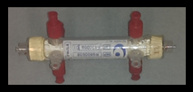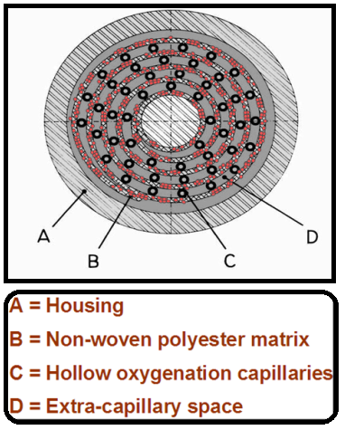
1C)
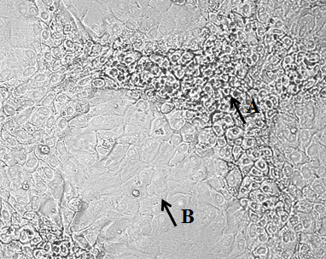

2. Materials and methods
2.1 HepaRG and C3A monolayer culture
HepaRG cells were kindly provided by Biopredic International (Rennes, France). HepaRG cells were maintained in William’s E–based culture medium (HepaRG medium), as described (3, 5). One group of HepaRG monolayers was kept for 4 weeks in 20%O₂ under regular conditions, i.e. static in an humidized atmosphere of 95% air and 5% CO2 (HepaRG-MONO). A second group was kept for the first 2 weeks under regular conditions and during the last 2 weeks under an atmosphere of 40%O₂, 5%CO₂ and 55%N₂ (HepaRG-40%O₂). A third group (monolayer with dynamic medium flow or HepaRG-DMF) was also cultured for the first 2 weeks under regular conditions, followed by 2 weeks shaking at 60 rpm under the same atmosphere. C3A cells (ATCC® CRL10741™) were cultured as described (8). For testing, C3A cells were seeded in 12-well plates and maintained in HepaRG medium for 2 weeks under regular culture conditions (C3A-MONO). All cultures were maintained at 37°C.

2.2 HepaRG and C3A AMC-BAL culture
A laboratory-scale version of the third generation AMC-BAL with an internal volume of 9 mL was used (Fig. 1). These AMC-BALs were loaded with 2 mL pellet of cryopreserved HepaRG or freshly isolated C3A cells suspended in 9 mL HepaRG medium, as described (10). The BAL cultures were incubated at 37°C and continuously oxygenated with a mixture of 40%O₂, 5%CO₂, 55%N₂. After a 3h-attachment phase, the AMC-BALs were continuously perfused at a rate of 5 mL/min with recirculating HepaRG culture medium. The medium was refreshed every 3 to 4 days (4). HepaRG-BAL and C3A-BAL cultures were analyzed after 21 and 14 days of culturing, respectively.

2.3 HepaRG-BALIAD culture
HepaRG cells were cultured on 6 mm (0.28 cm²) rounded discs DuPont™ Spunlaced Nonwoven Fabric- matrix, which is also used in the AMC-BAL, to provide a 3D configuration to the cells. To that goal, around 200.000 of HepaRG cells were seeded in matrices positioned in 96-well plates in 100 uL of HepaRG medium. After a 3h-attachment phase the matrices were moved to 1 mL HepaRG medium/well in 12-well plates and cultured under regular conditions for the first 2 weeks, followed by shaking at 60 rpm for the next 2 weeks in new plates. The medium was changed twice weekly.

2.4 HFLCs and MHHs isolation and culture
Human fetal livers were obtained from elective abortions. Gestational age was determined by ultrasonic measurement of the skull diameter and ranged from 14 to 18 weeks. The use of this tissue was approved by the Medical Ethical Committee of the Academic Medical Center, Amsterdam/Netherlands, subjected to informed consent in compliance with the Helsinki Declaration. We isolated HFLCs on three independent occasions; in each case four fetal livers were pooled. Cells were isolated as described previously (11, 12). HFLCs were seeded in DMEM culture medium (Dulbecco's modified Eagle's medium, BioWhittaker) containing 10% heat-inactivated fetal bovine serum (FBS, BioWhittaker), 2 mM L-glutamine (BioWhittaker), 1 μM dexamethasone (Sigma), 10 μg/mL insulin, 5.5 μg/mL transferrin, 6.7 ng/mL selenium-X (ITS mix, Life Technology), 100 U/mL penicillin, 100 μg/mL streptomycin (penicillin/streptomycin mix, BioWhittaker) at a density of approximately 3*10⁵ cells/cm² in Primaria 6-well plates (BD Falcon). Cells were kept for 2 days at 37°C in a humidified atmosphere (95% air, 5%CO2) before harvesting the total RNA. The purity of the isolation was confirmed by the measurement of transcript level of immature hepatic-markers including GSTл, AFP and CYP3A7, for more details refer to (11).
MHHs were isolated from tumor-free liver tissue of three patients undergoing partial hepatectomy, because of metastatic carcinoma. The procedure was approved by the Medical Ethical Committee of the Academic Medical Center subjected to informed patient consent. The hepatocyte isolation method was adapted from the protocol described by Seglen (13), as previously described (11). The MHHs were cultured in William’s E culture medium containing 4% heat-inactivated FBS, 2mM L-glutamine, 1uM dexamethasone, 20 mU/mL insulin (Novo Nordisk), 2mM ornithine (Sigma-Aldrich), 100U/mL penicillin, 100ug/mL streptomycin. Cells were kept for 2 days at 37°C in a humidified atmosphere (95% air, 5%CO2) before harvesting the total RNA.

2.5 Microarray analysis
Total RNA was isolated from HepaRG monolayers cultured for 4 weeks (HepaRG-MONO), from freshly isolated HepaRG cells cultured for 2 weeks in the AMC-BAL (HepaRG-BAL), and from MHHs and HFLCs monolayers cultured for 2 days, according to the protocol of the RNeasy Mini Kit (Qiagen® RNeasy Mini Kit) from 3 independent cultures/group. Quality control, RNA labeling, hybridization, and data extraction were performed at ServiceXS (Leiden, the Netherlands). Biotinylated cRNA was prepared using the Illumina TotalPrep RNA Amplification Kit (Ambion, Inc.) according to the manufacturer’s specifications with an input of 200 ng total RNA and hybridized to Illumina HumanHT-12 v4 microarrays. Scanning was performed on the Illumina iScan. Image analysis and extraction of raw expression data were performed with Illumina GenomeStudio v2011.1 Gene Expression software with default settings (no background subtraction and no normalization). Analyses were performed with Bioconductor packages (version 2.12) using the statistical software package R (version 3.0.0). Raw data normalization was performed on the Illumina sample and control probe proﬁles by a normexp-by-control background correction, quantile normalization, and log₂ transformation using the limma package (version 3.16.5). Based on quality control using the arrayQualityMetrics package (version 3.16.0) all arrays were deemed to be of sufficient quality. Probes with a detection P value > 0.05 (non-expressed) on all arrays (16,939 of 47,323 probes) were filtered out. Differential expression between the cell types was assessed with an empirical Bayes moderated t-test using the linear model framework from the limma package. Resulting P values were corrected for multiple testing using the Benjamini-Hochberg false discovery rate (FDR). Corrected P values <0.05 were considered as statistically significant. Probes were reannotated using the IlluminaHumanv4.db package (version 1.18.0). Low-quality probes that according to the updated probe annotation match repeat sequences, intergenic or intronic regions, or are unlikely to provide specific signal for any transcript (6,626 of 30,384) were filtered out. Gene sets were retrieved from the Molecular Signatures Database (MSigDB) v5.2. We selected the Hallmark and C5 (Gene Ontology) collections and the liver-specific gene set HSIAO_LIVER_SPECIFIC_GENES (C2), for more details see Hsiao et al 2001 (14). Gene set enrichment analysis was performed using CAMERA (limma package) with preset value of 0.01 for the inter-gene correlation using the same linear model as above. In case multiple probes mapped to the same Entrez Gene ID according to the updated probe annotation, the probe with highest standard deviation of its expression values was chosen. P values were calculated for each gene set for two alternative hypotheses (up or down). Hierarchical clustering of the whole-genome expression profiles and the profiles of the set of liver-specific genes was performed using Pearson correlation as distance measure and complete linkage as agglomeration method.

2.6 Quantitative reverse transcription PCR (RT-qPCR)
Total Quantitative RT-PCR was performed as previously described (7, 15). Transcript levels were normalized for 18S ribosomal RNA and expressed as a % of the average of two human liver samples. Primer sequences and amplicon sizes are given in Table 1.

2.7 Mitochondrial vs nuclear DNA ratio
The mitochondrial DNA (mtDNA) vs nuclear DNA (nucDNA) ratio was assessed as a measure of the mitochondrial abundance. Total DNA was isolated from AMC-BAL, BALIAD and monolayer cultures using the QIAamp DNA kits (QIAGEN® DNA Mini Kit) protocol.
Quantitative PCR was performed on 20 ng DNA/sample, using primers of 2 nuclear genes, i.e. CCAAT/enhancer binding protein alpha (CEBPa) and N-acetyl transferase (NAT), and 2 mitochondria-encoded genes, i.e. mitochondrial-NADH dehydrogenase subunit1 (MT-ND1) and mitochondrial cytochrome c oxidase subunit 3 (MT-CO3). The input concentration of the different genes was calculated using the LinRegPCR program (16). Next, the ratio of the geometric mean of the concentration of mitochondrial genes to nuclear genes was calculated, then ratio data were transformed into log10 data to calculate the geometric mean of each group.

2.8 Mitochondrial inner membrane (MIM) complexes immune-blotting (WB)
Mitochondrial abundance was further determined by Western blot analysis of different mitochondrial proteins. Cell lysates of the different HepaRG cultures were obtained after incubation at 4°C in RIPA buffer (25 mM Tris (Bio-Rad), 150 mM NaCl (Merck), 0.1% SDS (Merck), 0.5% sodium deoxycholate (Sigma), 1% Triton X-100 (Bio-Rad), pH 7.4) containing 1% of protease inhibitor cocktail (Roche) for 30 minutes. The protein concentration of the samples was determined using the BCA protein assay kit (Pierce Biotechnology). Proteins were separated (40 µg of protein/sample) by 10% sodium dodecyl sulfate polyacrylamide gel electrophoresis and transferred by semi-dry electro-blotting on polyvinylidene difluoride membranes (Invitrogen). Membranes were blocked overnight at 4°C in TBST (150 mM NaCl, 50 mM Tris, 0.1% Tween 20 (Applichem), pH 7.5) with 5% milk powder (Nutrilon). Next day, membranes were incubated with the primary antibodies (1:2000 in 5% milk/TBST) for 4 h at 4°C. Primary antibodies used were mouse IgG antibodies directed against mitochondrial inner membrane (MIM) complexes, Complex II -Flavoprotein subunit of succinate dehydrogenase (ABCAM), MIM complex IV Cytochrome C oxidase subunit (ABCAM) and MIM complex V ATP synthase subunit 5A (ABCAM). Rabbit-anti-actin antibody (Sigma) was used to detect actin as loading control. Then the membranes were washed 3x with TBST and subsequently incubated for 1 h at room temperature with horseradish peroxidase-conjugated goat anti-mouse or goat anti-rabbit IgG antibody (Bio-rad) in 5% milk/TBST. The blots were incubated with a home-made enhanced chemiluminescence mix (100 mM Tris-HCl pH 8.5, 1.25 mM luminol (Fluka), 0.2 mM p-coumarin (Sigma) with freshly added 3 mM H₂O₂ (Merck) and proteins were visualized by using ImageQuant LAS 4000 (GE Healthcare Life Sciences). The expression level of the proteins quantified using ImageJ software (http://imagej.nih.gov/ij/).

2.9 Mitochondrial membrane potential activity _JC-1 staining
JC-1 staining was used to analyze the mitochondrial membrane potential. JC-1 a cationic dye, that exhibits potential-dependent accumulation in the mitochondrial matrix, indicated by a fluorescence emission shift from green (~529 nm) to red (~590 nm). Monolayer cultures, matrices of BAL–cultures and BALIADs were incubated with 0.5 mL of 4 µM JC-1 (Invitrogen) for 30 min at 37°C. Simultaneously, the cells were incubated with 1 µM verapamil (Sigma) to inhibit JC-1 efflux through activity of ATP binding cassette subfamily B member 1 (17). The JC-1 mitochondrial aggregates to monomer cytosolic form ratio was quantified by calculating red to green fluorescence (Fλ585/Fλ510), as measured by using a NOVOstar plate reader (BMG Labtech). The ratio data were transformed into log10 data to calculate the geometric mean of each group.

2.10 Statistical analysis
We performed Student’s t-tests for the comparison between two groups and one-way ANOVA test for comparison between >2 groups with Dunnett's post hoc test comparing the mean of the control group (HepaRG-MONO) with the mean of each of the other groups, and Tukey’s post hoc test to compare the mean of each group with the mean of every other group, using Prism version 7 (GraphPad Prism Inc.). Significance was indicated by # = P value <0.05, ## = P value <0.01 and ### = P value <0.001. Data was represented as mean ± SD.
3. Results
3.1 The hepatic expression profile of the HepaRG cells is more similar to that of MHHs than HFLCs
The whole-transcriptome profiles of the HepaRG-MONO, HepaRG-BAL, MHHs and HFLCs groups were determined using Illumina HumanHT-12 v4 microarrays (n=3/group). Hierarchical clustering analysis of the transcriptome profiles revealed that the HepaRG-MONO and HepaRG-BAL groups were most similar to each other and less similar to the MHHs and HFLCs groups (Fig. 2A).
2A)
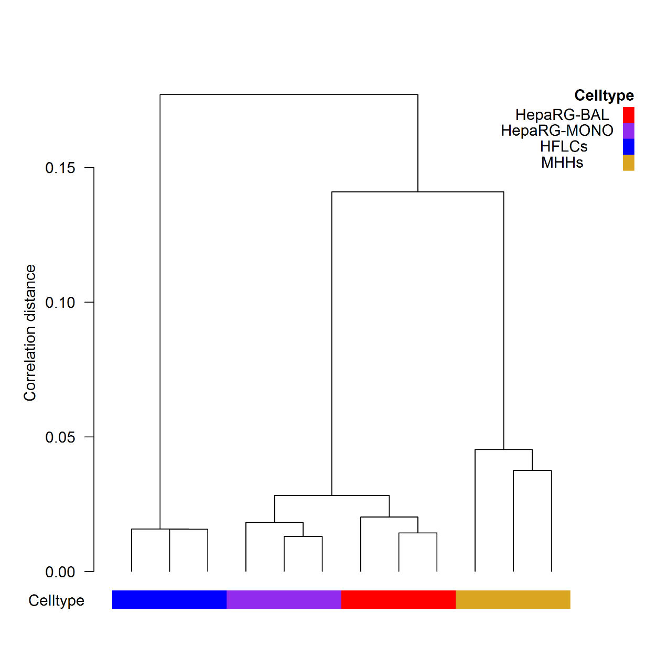
Figure 2: Transcriptome analysis of HepaRG cells, cultured in monolayer and BAL, and of primary hepatocytes, cultured in monolayer.
A) Hierarchical clustering based-dendrogram of the whole-genome expression profiles (n=3/group).
Considering that hepatic functionality is of major interest for clinical BAL applications, we further investigated the expression levels of a previously described set of 346 probes targeting human liver-specific genes (HSIAO_LIVER_SPECIFIC-GENES) in the four groups. The expression profile of the liver-specific genes in the HepaRG cells was more similar to the MHHs than to the HFLCs. Whereas the majority of the liver-specific genes showed a significantly higher expression in HepaRG-MONO and HepaRG-BAL compared to HFLCs, yet, when relating to MHHs, the expression of liver-specific genes in the HepaRG-MONO and HepaRG-BAL groups was relatively low. Again, of the four groups, the HepaRG-MONO and HepaRG-BAL groups were most similar in their expression profile of the liver-specific genes (Fig. 2B).
2B)
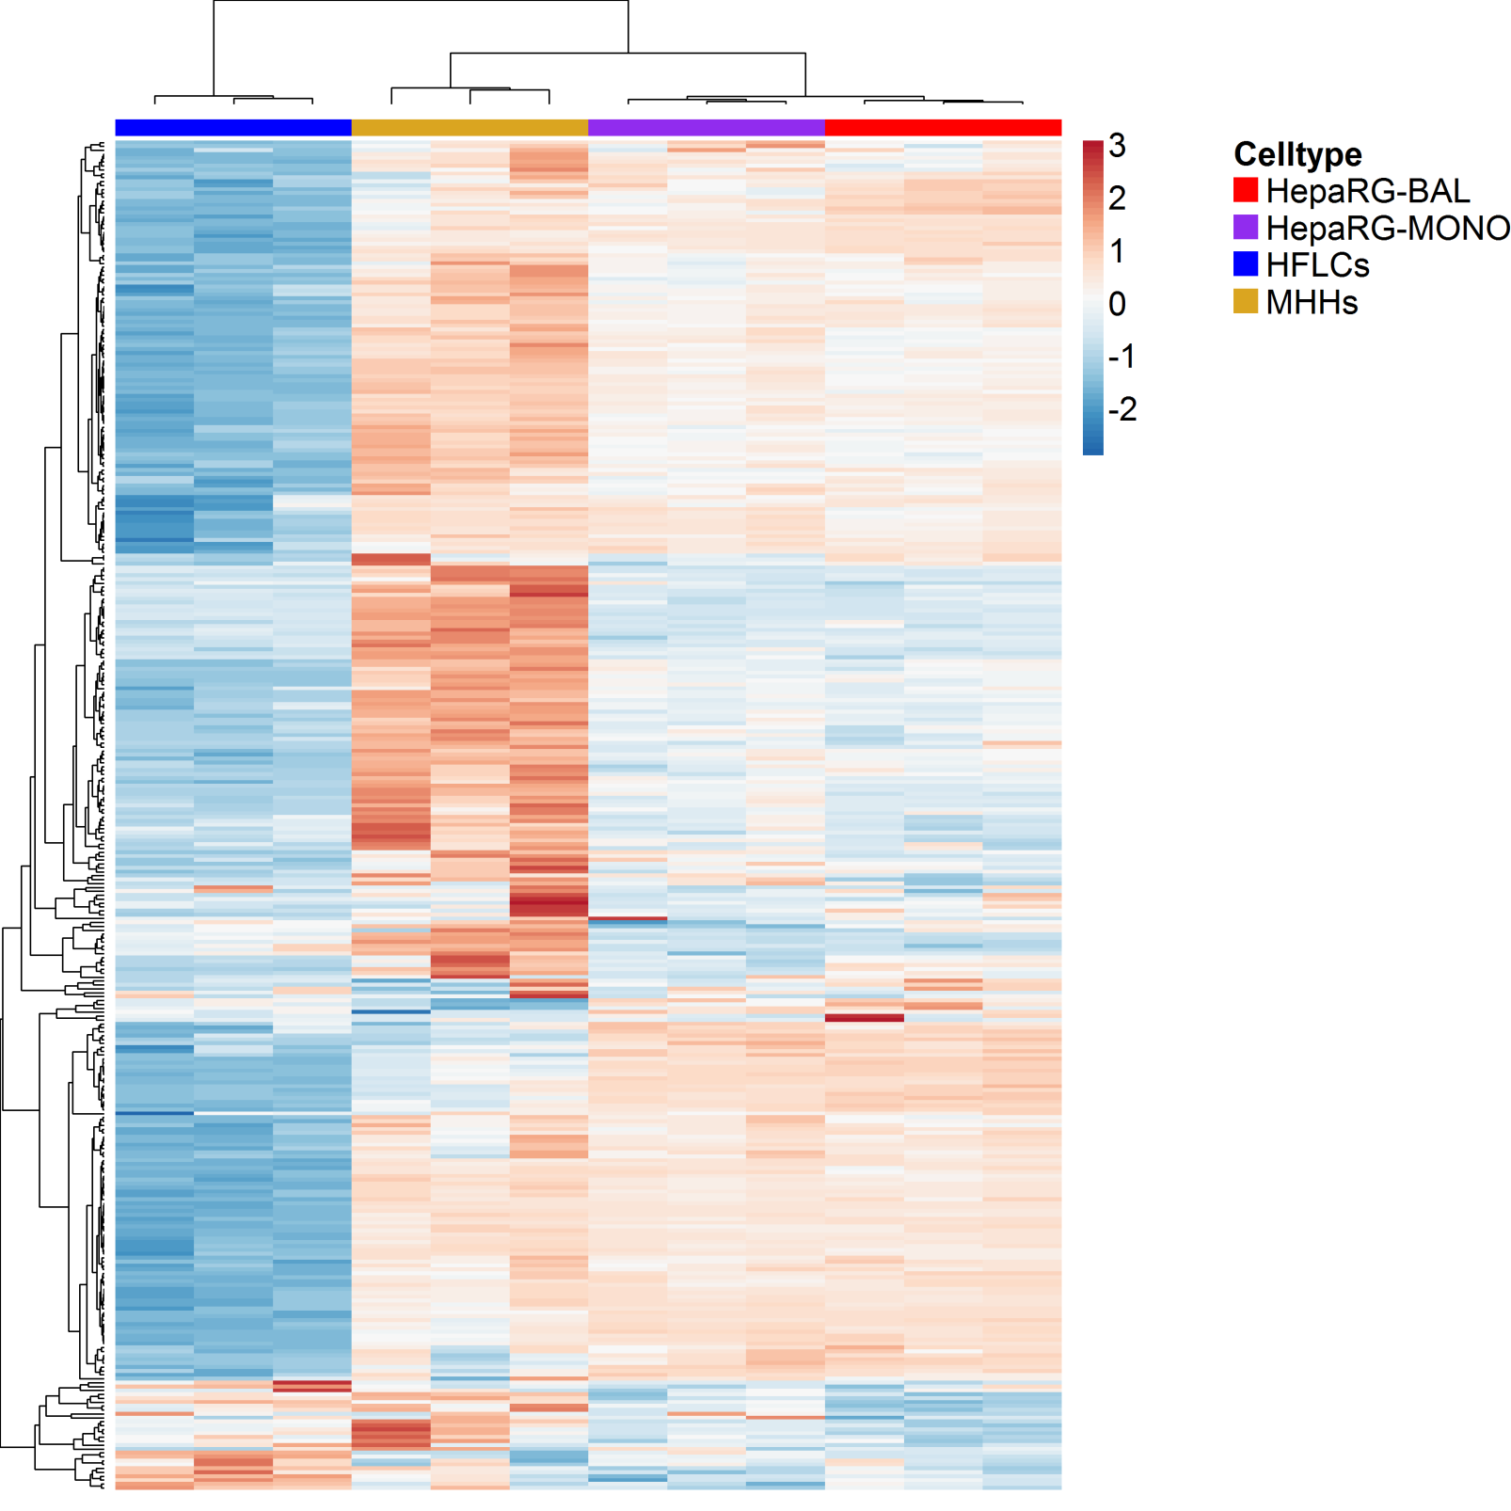
Figure 2: Transcriptome analysis of HepaRG cells, cultured in monolayer and BAL, and of primary hepatocytes, cultured in monolayer.
B) Heatmap of hierarchical clustering on the expression profiles of a previously described set of 346 probes targeting human liver-specific genes (HSIAO_LIVER_SPECIFIC_GENES), (n=3/group). The key color bar indicates standardized gene expression levels.

3.2 AMC-BAL culture positively regulates the expression of genes involved in energy metabolism and mitochondria in HepaRG cells
To determine which factors could explain the differences in metabolic functioning between HepaRG-BAL and HepaRG-MONO cells, we first identified probes that were differentially expressed between the two groups. Only 175 out of 23,758 probes (~0.7%) were identified as differentially expressed (adjusted P value <0.05) between HepaRG-BAL and HepaRG-MONO. Among the top 20 up-regulated genes (Table 2), in the HepaRG-BAL compared to HepaRG-MONO were liver-specific genes, including those encoding apolipoprotein A2 (ApoA2), which is the second most abundant protein of the high density lipoprotein particles, CYP3A4; a cytochrome p450 enzyme involved in the metabolism of approximately 50% of the drugs in use (18), and oxidative stress-induced growth inhibitor 1 (OSGIN1) , which is stimulated by oxidized phospholipids to regulate cell response to oxidative stress (19). Recently, OSGIN1 was found to regulate mitochondrial structure and function through a direct interaction with P53 (20). In addition, the gene encoding Dishevelled binding antagonist of beta catenin 3 (DACT3), an epigenetic and negative regulator of Wnt/beta-catenin signaling pathway, was induced under BAL culture. The Wnt/beta-catenin signaling pathway regulates stem cell pluripotency and cell fate decisions, and is associated with carcinogenicity (21-23). This signaling pathway also plays a central role in governing the hepatic zonation along liver sinusoids (24). The top 20 down-regulated genes contained several cancer-related genes, including H19, IGFBP5, MCF2, SPANXA1, SPANXE and SPANXD (Table 3).
Gene-set enrichment analysis was performed using CAMERA (25) to identify gene-sets that are highly ranked in terms of differential expression in HepaRG-BAL vs HepaRG-MONO relative to genes not in the set. In total 85 gene-sets with FDR< 0.05 were identified, among which 48 were up-regulated and 37 were down-regulated in HepaRG-BAL compared to HepaRG-MONO. The majority of the up-regulated gene-sets were directly related to energy metabolism and mitochondria, whereas, most of the down-regulated gene-sets were involved in cell-cycle regulation, (Fig. 3A-B).

3A)
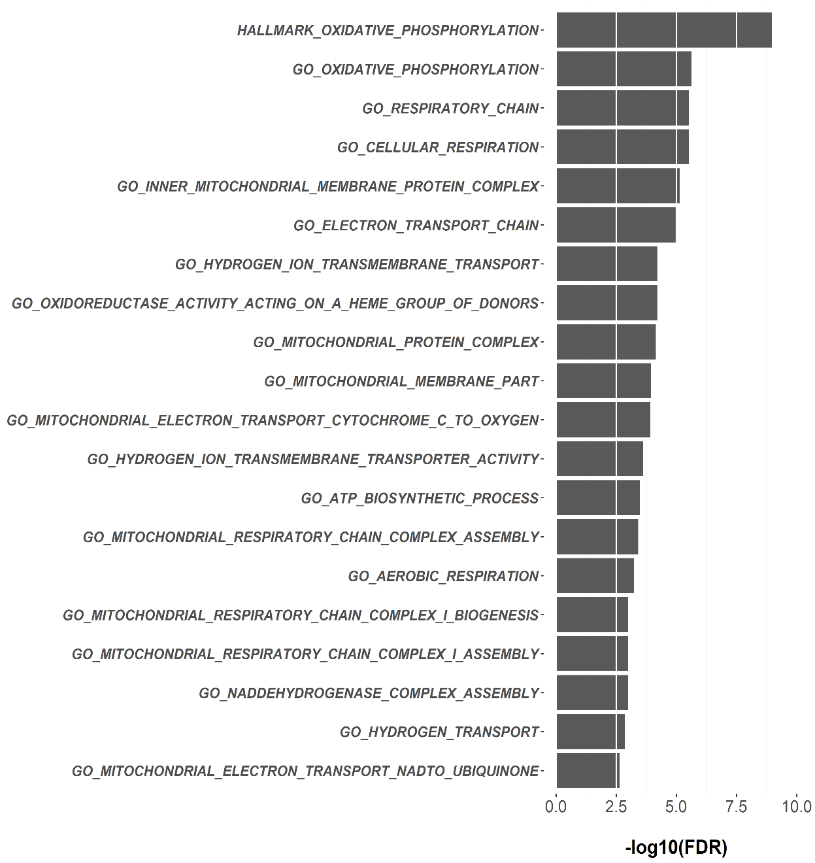

3B)
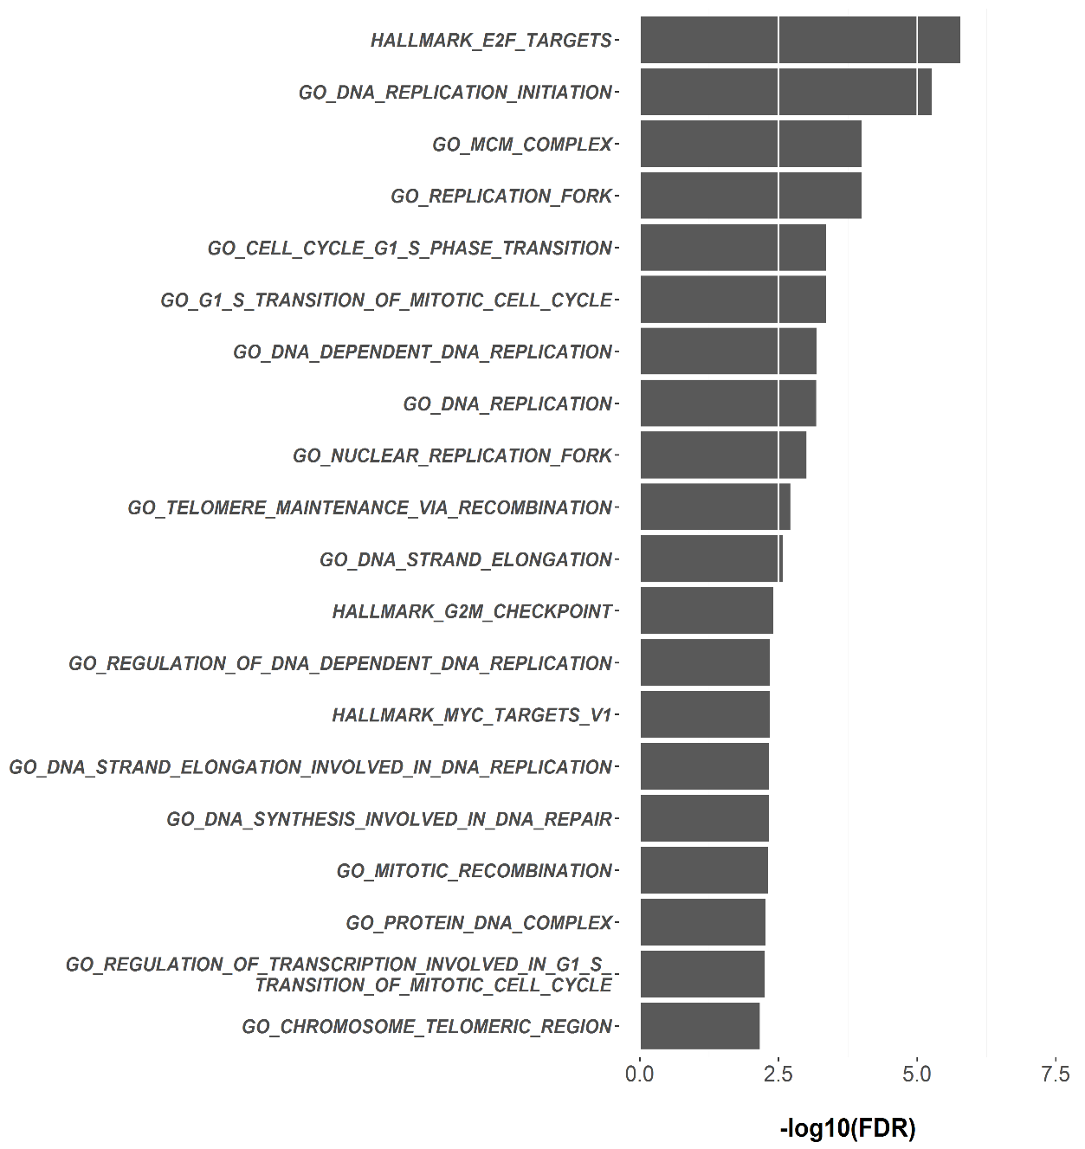
Figure 3: AMC-BAL culture positively regulates the expression of genes involved in energy metabolism and mitochondria in HepaRG cells.
A-B) Top 20 up- and down-regulated Gene-sets between HepaRG-BAL and HepaRG-MONO (FDR: Benjamini-Hochberg adjusted p value).

A representative example of an up-regulated gene-set related to mitochondria is shown in (Fig. 3C) with a selection of up- and down-regulated genes highlighted. Up-regulated genes include NDUFB9 and UQRC1 which encode proteins related to OxPhos complex I and III, respectively, and CS, ACO2 and CPT1A which are involved in TCA cycle and β-oxidation. In contrast, the down-regulated gene SLC25A14 (known also as UCP5) is a mitochondrial uncoupling protein that functions to separate OxPhos from ATP generation with the energy dissipated in form of heat. Also down-regulated is ABCA12 which is involved in the regulation of cellular cholesterol metabolism at posttranscriptional level (26).
3C)
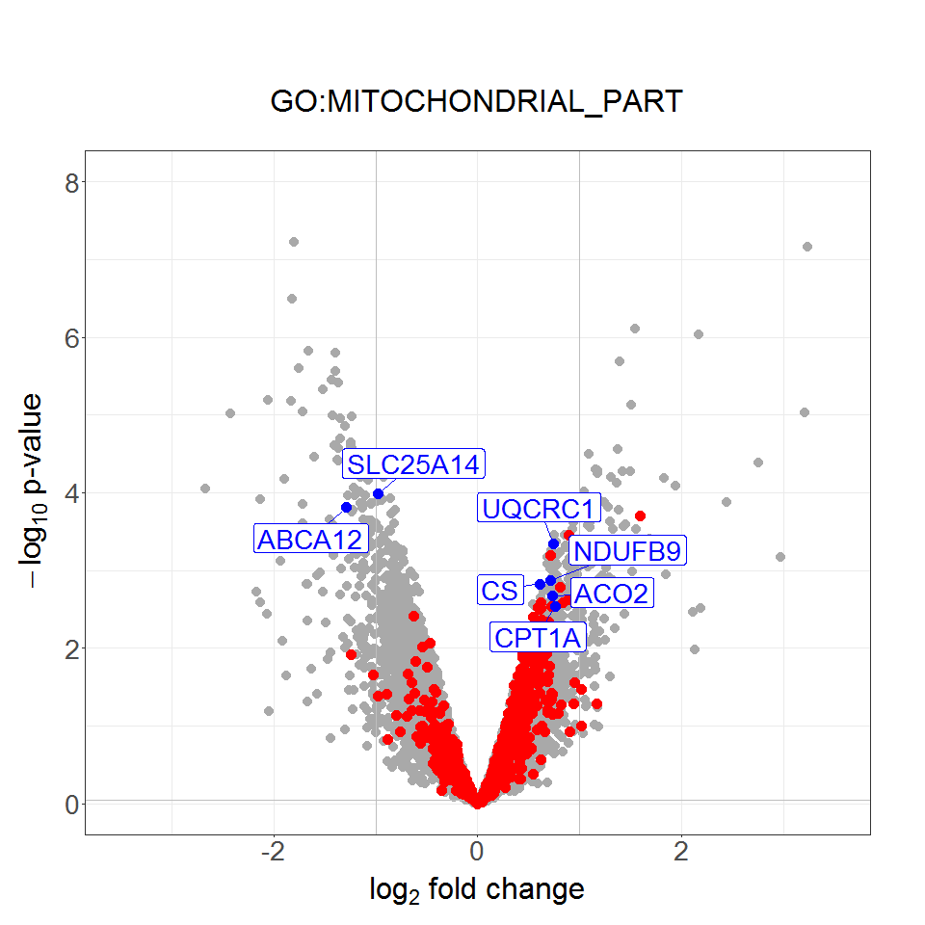
Figure 3: AMC-BAL culture positively regulates the expression of genes involved in energy metabolism and mitochondria in HepaRG cells.
C) Volcano plot displaying gene-set “Mitochondrial part” that contains 839 genes and was significantly up-regulated (HepaRG-BAL vs HepaRG-MONO) in the CAMERA analysis (FDR=0.006). Genes included in the indicated gene-set are marked in red, selected examples of up and down-regulated genes discussed in the text are marked in blue and the other genes are marked in grey.

This clear shift towards up-regulation of genes involved in mitochondrial energy metabolism by BAL culturing prompted us to further investigate mitochondrial biogenesis in the context of the BAL culturing.
3.3 AMC-BAL culturing enhances mitochondrial biogenesis in the HepaRG cells, an effect driven by the 3D configuration, dynamic medium perfusion and higher oxygenation (40%O₂)
Mitochondria provide the cell with ATP through oxidative phosphorylation (OxPhos) activity (27), and therefore the abundance of mitochondria is finely tuned to meet cell-and state-specific energy needs (28). When compared to other subcellular organelles, the mitochondrion is unique in possessing a separate autonomously replicating genome and its own translation machinery (29).
We investigated the effect of BAL culturing on mitochondrial biogenesis. As outlined in the introduction, the three major differences between the AMC-BAL culture and the regular monolayer comprise the oxygenation (40%O₂ in the AMC-BAL vs 20%O₂ in monolayer), presence (AMC-BAL) or absence (monolayer) of medium perfusion and culture configuration (3D in the AMC-BAL vs 2D in monolayer).
To study the effect of the different factors, we applied different culture conditions to the differentiation phase. We tested the effect of oxygenation in HepaRG monolayers cultured under 40%O₂ (HepaRG-40%O₂) and the effect of dynamic medium flow on monolayers cultured under 60 rpm supplied with 20%O₂ (HepaRG-dynamic medium flow (HepaRG-DMF). To study the joint effect of 3D configuration and DMF on mitochondrial biogenesis, we developed the BAL-in-a-dish culture platform (HepaRG-BALIAD). The BALIAD system consists of 6 mm diameter discs of BAL matrix that are placed in cell culture plates under continuous shaking with 20%O₂ supply, a graphic representation of different culture conditions is shown in (Fig. 4A).
Parameters of mitochondrial biogenesis of these 3 different culture conditions and HepaRG-BAL cultures were compared to those of control static HepaRG monolayer cultures supplied with 20%O₂ (HepaRG-MONO).
The relative mitochondrial abundance was determined by measuring the ratio between mitochondrial DNA to nuclear DNA copies (mtDNA/NucDNA ratio). The relative mitochondrial abundance was significantly increased up to 2.4-fold in the HepaRG-BAL compared to the HepaRG-MONO group (Fig.4B). Culturing of the HepaRG cells with 40%O₂, DMF or BALIAD, positively affected the abundance of the mitochondria as indicated by a 2.1-, 3.3- and 5.1-fold increase, respectively. Noteworthy, mitochondrial abundance was not significantly different between HepaRG-BAL, HepaRG-40%O₂, HepaRG-DMF and HepaRG-BALIAD.

4A)
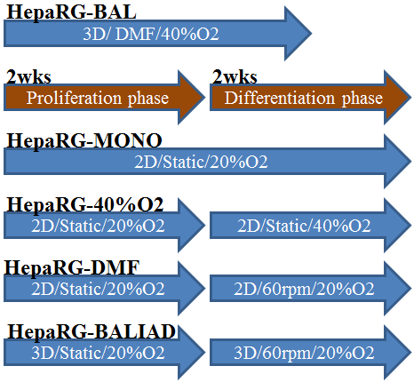
4B)
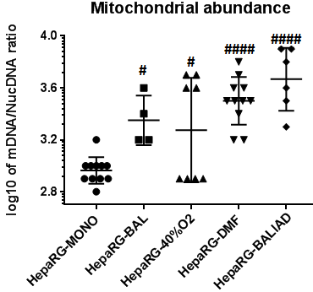
Figure 4: Mitochondrial biogenesis in HepaRG cells cultured in monolayer and BAL; the role of higher oxygenation (40%O₂), DMF and 3D configuration
A) Graphic representation of different culturing conditions. B) Mitochondrial abundance measured by mtDNA/NucDNA ratio (n=4 for HepaRG-BAL and n=8-11/other groups).

In line with this, the expression of the mitochondrial inner membrane (MIM) complex II was 2.4-, 1.9- 2.3- and 2.1-fold increased in HepaRG-BAL, HepaRG-40%O₂, HepaRG-DMF and HepaRG-BALIAD, resp., while, MIM complex IV was 2.2- and 2.5-fold increased in HepaRG-BAL and HepaRG-DMF. compared to HepaRG-MONO cultures. The expression of MIM complex V was 2.3-, 1.9 and 2.3-fold induced in HepaRG-BAL, HepaRG-40%O₂ and HepaRG-DMF cultures. Noteworthy, no significant differences was observed in the level of MIM complexes when HepaRG-BAL was compared to HepaRG-40%O₂, HepaRG-DMF or HepaRG-BALIAD, (Fig. 4C-D).

4C)
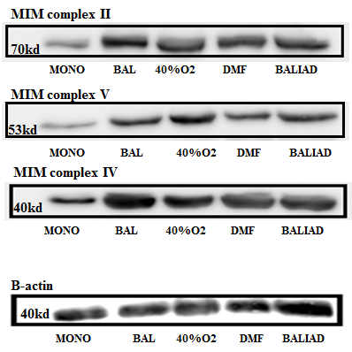
4D)
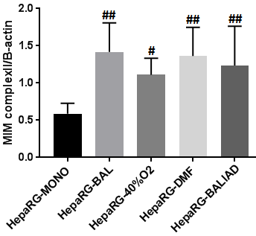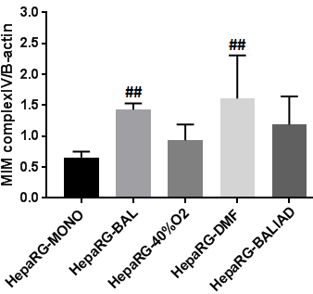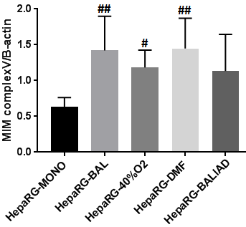
Figure 4: Mitochondrial biogenesis in HepaRG cells cultured in monolayer and BAL; the role of higher oxygenation (40%O₂), DMF and 3D configuration
C) Mitochondrial abundance measured by the expression level of mitochondrial inner membrane complexes (MIM complexes) complex II, IV and V, as determined by immune-blotting (n=4-9/group). D) Quantification of the immunoblots.

Furthermore, the transcript levels of the mitochondria-encoded genes MT-ND5, MT-CYB and MT-ATP6 were 2.9-, 3.6- and 3.6-fold induced in HepaRG-BAL compared to HepaRG-MONO, reaching 93.1%, 142.6% and 142.1% of human liver transcript levels, respectively (Fig. 4E). On the other hand, the transcript levels of MT-ND5, MT-CYB and MT-ATP6 were only significantly increased in the HepaRG-DMF vs HepaRG-MONO cultures by 1.8-, 1.9- and 2-fold respectively and remained unchanged in the HepaRG-40%O₂ and HepaRG-BALIAD cultures.

4E)
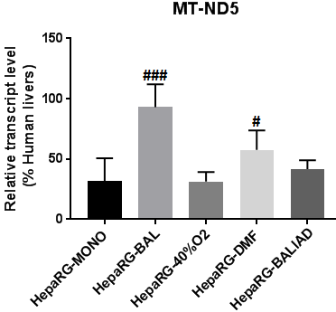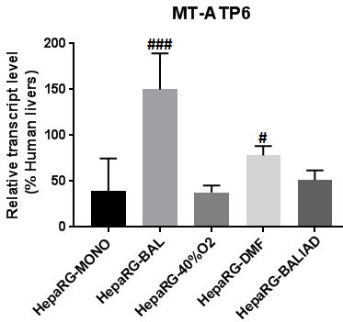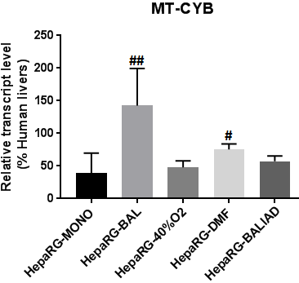
Figure 4: Mitochondrial biogenesis in HepaRG cells cultured in monolayer and BAL; the role of higher oxygenation (40%O₂), DMF and 3D configuration
E) Transcript level of mitochondria-encoded genes (n=6-8/group), data

Next, we assessed whether the increased mitochondrial biogenesis by BAL culturing was also associated with an increase in mitochondrial membrane-potential activity (MMPA), through JC-1 staining. MMPA was 8.3- and 3.2-fold increased in the HepaRG-BAL and HepaRG-BALIAD compared to the HepaRG-MONO group, while it remained comparable to HepaRG-MONO in HepaRG-DMF and HepaRG-40%O₂ groups (Fig.4F).The JC-1 staining showed cluster patterns in the cultures (HepaRG-BAL cultures not included), which were not specifically confined to hepatocyte islands (Fig. 4G).
4F)
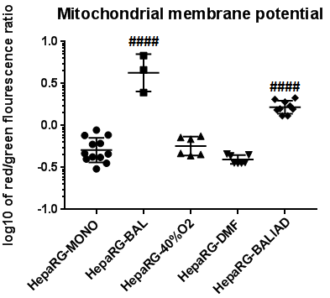
4G)
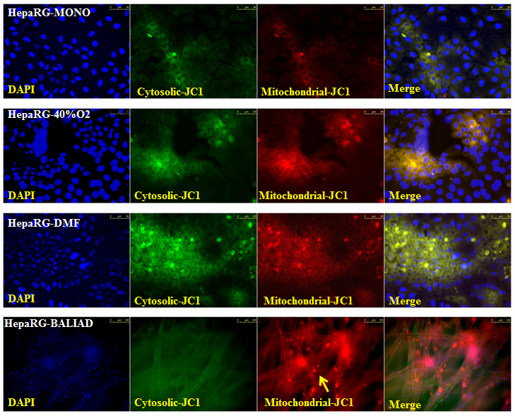
Figure 4: Mitochondrial biogenesis in HepaRG cells cultured in monolayer and BAL; the role of higher oxygenation (40%O₂), DMF and 3D configuration
F) Quantification of the JC-1 staining, by calculating red (mitochondrial JC-1 fraction) to green (cytosolic JC-1 fraction) fluorescence ratio (n=3-12/group). G) Imaging of mitochondrial JC-1 staining in HepaRG-MONO, HepaRG-40%O₂, HepaRG-DMF and HepaRG-BALIAD from top to bottom respectively. The scale bar is 50 µm for the upper 3 panels and 100 µm for the lowest panel (BALIAD). To elucidate the 3D configuration, the arrow indicates a BALIAD matrix fiber to which the HepaRG cells attach.

Taken together, these data provide evidence that BAL culturing increases mitochondrial abundance and MMPA in HepaRG cells. The 3D configuration, DMF and high oxygenation exert a positive effect on mitochondrial biogenesis as confirmed by both mtDNA/NucDNA ratio and western blot results, however only BALIAD cultures, which are closely mimicking the BAL platform by combining DMF with 3D configuration, exhibited increased MMPA as measured by JC-1 staining.

3.4 Promotion of mitochondrial biogenesis by BAL culturing is a general phenomenon
To assess whether the effect of the AMC-BAL culturing on mitochondrial biogenesis is a general effect of the BAL culture or HepaRG cells-dependent, mitochondrial biogenesis was also studied in the hepatoma cell line C3A. BAL-cultured C3A cells showed 2.2-fold increased mitochondrial abundance compared to C3A monolayers (Fig. 5A), which was a similar fold up-regulation compared to HepaRG cells. Notably, the mtDNA/nucDNA ratio was 1.7- and 1.8- fold higher in HepaRG-MONO and HepaRG-BAL compared to C3A-MONO and C3A-BAL, respectively.
5A)

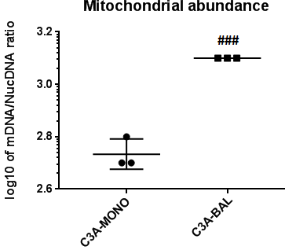
Moreover, the transcript levels of mitochondria-encoded genes, specifically, MT-ND1, MT-ND5, MT-CO3, MT-ATP6, MT-ATP8 and MT-CYB, were 3.8-, 2.6-, 4.0-, 3.6-, 4.1- and 3.2-fold induced in the C3A-BAL compared to the C3A-MONO group, reaching 92.5%, 57%, 94.9%, 72.4%, 90.8% and 59.1% of human liver transcript levels, respectively (Fig. 5B). Thus, the stimulatory effect of AMC-BAL culturing on mitochondrial biogenesis is a general phenomenon and not restricted to HepaRG cells.

5B)
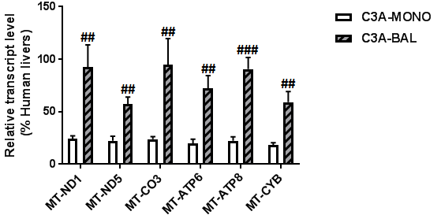
Figure 5: Mitochondrial biogenesis in human liver cell line C3A cultured in monolayer and BAL.
A) Mitochondrial abundance measured by mtDNA/NucDNA ratio. B) Transcript level of mitochondria-encoded genes (n=3/group).

4. Discussion & Conclusions
In vitro models of highly functional, and well-differentiated hepatocytes from proliferative sources are needed. Usability of in vitro cultured primary hepatocytes are limited by scarcity of the material and rapid dedifferentiation, while hepatocytes from proliferative sources still fail to show the full functionality spectrum (1). Therefore it is essential to improve the hepatic differentiation methods of proliferative hepatocyte sources. Previously, we found that AMC-BAL culturing improves the hepatic functionality of HepaRG cells compared to monolayers (7, 8). In the current study we found that BAL culturing additionally enhances the mitochondrial biogenesis in HepaRG cells. The contributing factors to this increased mitochondrial biogenesis are 3D configuration, DMF and high oxygenation (40%O₂). All of the three investigated factors exerted a stimulatory effect on mitochondrial biogenesis and hence contributed, probably in a synergistic way, to the positive effect of the BAL culturing on mitochondrial biogenesis. In fact, these 3 factors jointly, closely model the liver in vivo where the hepatocytes receive continuous perfusion of highly oxygenated blood from the hepatic arterio-venous system with a mean oxygen saturation of 72.9% (30) and the cells are in a 3D intimate contact with other non-parenchymal liver cells. In addition, the stimulatory effect of the AMC-BAL culture on mitochondrial biogenesis was confirmed in another hepatoma cell line, C3A, indicating that it is a general effect of the BAL culture and not a HepaRG-dependent effect.

Our observation that BAL culturing of HepaRG cells increased mitochondrial biogenesis and activity is in line with our previous finding that HepaRG monolayer cultures produced lactate, while HepaRG-BAL cultures eliminated lactate and consumed glucose at a lower rate (7, 8), indicating a shift in energy metabolism from glycolysis towards OxPhos. In addition, lactate production by C3A cells in monolayer was completely abolished by BAL culturing (8). The hepatic functionality of the C3A cells is relatively low compared to HepaRG cells. Similarly, we found that HepaRG monolayers and BALs displayed a doubled mitochondrial abundance compared to C3A monolayers and BALs respectively. Therefore, we find a strong association between mitochondrial energy metabolism and hepatic differentiation of these two liver cell lines which may apply to hepatogenic differentiation in general.

Currently, the strong association between mitochondrial energy metabolism and cell differentiation receives much attention in stem cell studies. Undifferentiated stem cells retain pluripotency and unlimited proliferative capacity under conditions ideally mimicking the original relatively anaerobic stem-cell niche. In this state, energy metabolism relies on high glycolysis and mitochondria are immature (31, 32). Upon differentiation, mitochondrial remodeling takes place leading to a shift of energy metabolism towards OxPhos (31, 33, 34). Evidence is accumulating that this shift in energy metabolism is in fact a causal factor for the differentiation of stem cells. Promoting or inhibiting mitochondrial biogenesis or function severely impact the stemness (32, 35-38). The reprogramming of somatic cells into induced pluripotent cells and the in vitro dedifferentiation of primary hepatocytes, on the other hand, are coupled to inverse modifications of the mitochondrial system, in a process called “mitochondrial rejuvenation” (33, 36, 39-41). In a large-scale transcriptomic and proteomic study, Lauschke et al, observed that early changes associated with hepatic dedifferentiation related, in part, to inhibition of major metabolic pathways such as TCA cycle, β-oxidation and OxPhos (42). These findings collectively render the hypothesis that a shift to mitochondrial biogenesis and OxPhos is a causative factor in hepatocyte differentiation, very plausible.

In the past, high oxygenation, DMF, and 3D culturing have been applied to increase the differentiation of hepatocyte or liver cell line cultures. Our group showed that increasing oxygenation level by increasing the number of gas capillaries inside the BAL system as well as by increasing oxygen pressure from 135-150 mm Hg (20%O₂) to 235-250 mm Hg (40%O₂) both enhanced hepatic functions and transcript level of liver-specific genes in primary pig hepatocytes (43). In addition, rat hepatocyte spheroids maintained under different oxygen tensions exhibited increased urea and albumin production under 21%O₂ vs 6% O₂. However, the use of a high oxygen tension (95%O₂) without supplementation of antioxidants negatively affected the functionality of the spheroids, due to accumulation of reactive oxygen species (ROS) (44). Yet, another study reported that high oxygen (95%O₂) supply to primary rat hepatocytes co-cultured with either fibroblast (3T3-J2) or endothelial cells, positively affected their functions, including ammonia elimination, urea and albumin production and the detoxification capacity (45, 46).
DMF has also previously been recognized as an important factor, in addition to oxygenation, that stimulates hepatic differentiation. Rat hepatocytes co-cultured with 3T3-J2 fibroblasts under DMF supplemented with an internal oxygenation system showed elevated rates of albumin synthesis and urea production (47, 48). We previously found that the functionality of the HepaRG cells in the AMC-BAL system strongly depends on optimal medium perfusion at 5 mL/min perfusion rate. Lower perfusion rates (0.3 and 1.5 mL/min) decreased functionality, while a higher rate (10 mL/min) increased cell damage (49).
In addition, culturing in 3D configuration, most often utilizing spheroids, has been found to stimulate hepatic functionality in primary hepatocytes (50, 51) and in liver cell lines (52). A combination of 3D culturing and DMF positively affected the differentiation of the liver cell lines HepG2 and C3A, as assessed by morphology and albumin synthesis (53, 54). However, none of these studies related the enhanced hepatic differentiation to increased mitochondrial biogenesis. We provide for the first time evidence that these differentiation promoting culture conditions are tightly associated with mitochondrial biogenesis. In particular, the combination of DMF and 3D culturing, as established in the BALIAD culture set-up, proved to substantially increase mitochondrial biogenesis.

When comparing mitochondrial biogenesis parameters between different culturing platforms, we found a discrepancy between mitochondrial abundance (mtDNA and the expression of the OxPhos complexes) from one side and mitochondrial activity (MMPA) from the other side. While mitochondrial abundance increased in the HepaRG-BAL, HepaRG-40%O₂, HepaRG-DMF and HepaRG-BALIAD compared to HepaRG-MONO, only HepaRG-BAL and HepaRG-BALIAD exhibited an increased MMPA. MMPA is critical for maintaining the physiological function of the respiratory chain to generate ATP. A significant loss of MMPA renders cells depleted of energy and subsequently induces apoptosis (55). Explanations for this unexpected finding may be related to either increased ROS generation or mitochondrial immaturity under 40%O₂ and DMF cultures. Furthermore, the regulation of mitochondrial polarization might be different in 3D cultures (BAL and BALIAD) compared to 2D monolayers (HepaRG-MONO, HepaRG-40%O₂ and HepaRG-DMF), However, this requires further investigations.

Despite the substantial improvement in the hepatic functions of the HepaRG cells upon AMC-BAL culturing, the transcriptional profile of a set of liver-specific genes remained to some extent comparable to that of monolayer cultures, which suggests that post-translational modifications play an important role in the gain of functionality. We postulate that two major consequences of the shift in energy metabolism may affect the hepatic functionality, including a shift in the concentration of nutrient metabolites and ROS. Firstly, the change in energy metabolism yields a different spectrum of nutrient metabolites that could directly change flux rates of metabolic pathways. For instance, amino acids regulate many critical metabolic pathways, such as gluconeogenesis as well as the urea and TCA cycles (56). Previously we already showed that BAL-cultured HepaRG and C3A cells display an amino acids metabolome profile different from that of monolayer cultures (7, 8). Furthermore, accumulation of metabolites mainly detoxified through mitochondria, such as lactate and ammonia, may severely impact hepatocyte viability and functions (57). BAL-cultured HepaRG cells efficiently eliminate lactate and ammonia, whereas monolayer cultures produce lactate and eliminate ammonia to a lesser extent. Secondly, as a by-product of energy generation through OxPhos, ROS may play a role in post-transcriptional regulation of hepatic functionality by oxidation of lipids, proteins and RNA (58). Low ROS levels are found in cells with reduced mitochondrial metabolism, as stem cells, to conserve the self-renewal capacity and to protect the genome of these rapidly dividing cells. On the other hand, increased levels of ROS favor cell differentiation (59, 60). The transcript level of OSGIN1 was induced in BAL-cultured HepaRG cells, reflecting the increased OxPhos activity, and subsequently increased ROS production (19). Recently, OSGIN1 was also identified as a tumor suppressor that is down-regulated or mutated in human hepatocellular carcinoma tissues (61). It will be, however, difficult to distinguish between the different players that may post-transcriptionally increase the hepatic functionality during BAL culturing, due to interconnections between the processes regulated by the concentration of energy metabolites and ROS.
Interestingly, the hepatic transcriptome of the HepaRG was more similar to MHHs than to HFLCs. The relatively high similarity of HepaRG cells with MHHs was previously also found in a global transcriptome study comparing HepaRG, MHHs and HepG2 cells (62). A recent study by Gao et al, compared the global gene expression profiles of human induced pluripotent stem cells subjected to hepatogenic-differentiation protocol (iPSC-Heps) to that of MHHs and several human hepatoma cell lines (HepaRG, HuH-7, HepG2, and HepG2/C3A). Among all other studied hepatoma cell lines and iPSC-Heps , the HepaRG cells were most similar to MHHs (63). Yet, when compared to the whole-transcriptome profile of MHHs, the profile of the HepaRG cells clearly deviates, indicating that there is still room for further optimization of HepaRG cells. New culture platforms that are capable to enhance mitochondrial metabolism and subsequently the functionality through 3D culture and medium perfusion, such as the BALIAD system, could provide in this need. Besides optimizing the culture platform, interfering with the mitochondrial system by over-expression of master regulators of mitochondrial biogenesis, such as Peroxisome proliferator-activated receptor gamma coactivator 1-alpha or addition of chemical compounds that stimulate mitochondrial biogenesis, e.g. S-nitrosoacetylpenicillamine or metformin may boost the differentiation process (64-66).

Taken together, the data presented in this paper demonstrate that AMC-BAL culturing enhances mitochondrial biogenesis in two different human liver cell lines. These findings establish an association between hepatic differentiation and mitochondrial biogenesis in the context of BAL culturing. Importantly, we identified three factors related to culture conditions that positively regulate mitochondrial biogenesis: oxygenation level, medium flow and 3D configuration of the culture. In particular the BALIAD culture set-up yielded improvement of mitochondrial biogenesis as well as MMPA. This culture set-up is easily applicable and scalable, and may therefore be a substantial improvement to the current monolayer set-up for obtaining higher levels of hepatic differentiation of human liver cell lines or stem cells.

Acknowledgements
The authors thank Tanja Deurholt and Kees Weijer for the isolation of the HFLCs.
References list
1. van Wenum M, Chamuleau RA, van Gulik TM, Siliakus A, Seppen J, Hoekstra R. Bioartificial livers in vitro and in vivo: tailoring biocomponents to the expanding variety of applications. Expert Opin Biol Ther. 2014;14(12):1745-60.
2. Flendrig LM, la Soe JW, Jorning GG, Steenbeek A, Karlsen OT, Bovee WM, et al. In vitro evaluation of a novel bioreactor based on an integral oxygenator and a spirally wound nonwoven polyester matrix for hepatocyte culture as small aggregates. JHepatol. 1997;26(6):1379-92.
3. Gripon P, Rumin S, Urban S, Le Seyec J, Glaise D, Cannie I, et al. Infection of a human hepatoma cell line by hepatitis B virus. Proc Natl Acad Sci U S A. 2002;99(24):15655-60.
4. Nibourg GA, Chamuleau RA, van der Hoeven TV, Maas MA, Ruiter AF, Lamers WH, et al. Liver progenitor cell line HepaRG differentiated in a bioartificial liver effectively supplies liver support to rats with acute liver failure. PLoSOne. 2012;7(6):e38778.
5. Hoekstra R, Nibourg GA, van der Hoeven TV, Ackermans MT, Hakvoort TB, van Gulik TM, et al. The HepaRG cell line is suitable for bioartificial liver application. IntJBiochemCell Biol. 2011;43(10):1483-9.
6. van Wenum M, Treskes P, Tang CY, Coppens EJ, Jansen K, Hendriks EJ, et al. Scaling-up of a HepaRG progenitor cell based bioartificial liver: optimization for clinical application and transport. Biofabrication. 2017;9(3):035001.
7. Nibourg GA, Hoekstra R, van der Hoeven TV, Ackermans MT, Hakvoort TB, van Gulik TM, et al. Increased hepatic functionality of the human hepatoma cell line HepaRG cultured in the AMC bioreactor. IntJBiochemCell Biol. 2013;45(8):1860-8.
8. van Wenum M, Adam AA, Hakvoort TB, Hendriks EJ, Shevchenko V, van Gulik TM, et al. Selecting Cells for Bioartificial Liver Devices and the Importance of a 3D Culture Environment: A Functional Comparison between the HepaRG and C3A Cell Lines. Int J Biol Sci. 2016;12(8):964-78.
9. Knowles BB, Howe CC, Aden DP. Human hepatocellular carcinoma cell lines secrete the major plasma proteins and hepatitis B surface antigen. Science. 1980;209(4455):497-9.
10. Nibourg GA, Chamuleau RA, van Gulik TM, Hoekstra R. Proliferative human cell sources applied as biocomponent in bioartificial livers: a review. ExpertOpinBiolTher. 2012;12(7):905-21.
11. Deurholt T, ten BL, Chhatta AA, van Wijk AC, Weijer K, Seppen J, et al. In vitro functionality of human fetal liver cells and clonal derivatives under proliferative conditions. Cell Transplant. 2006;15(8-9):811-22.
12. Deurholt T, van Til NP, Chhatta AA, ten BL, Schwartlander R, Payne C, et al. Novel immortalized human fetal liver cell line, cBAL111, has the potential to differentiate into functional hepatocytes. BMCBiotechnol. 2009;9:89.
13. Seglen PO. Hepatocyte suspensions and cultures as tools in experimental carcinogenesis. J Toxicol Environ Health 1979;5(2-3):551-60.
14. Hsiao LL, Dangond F, Yoshida T, Hong R, Jensen RV, Misra J, et al. A compendium of gene expression in normal human tissues. Physiol Genomics. 2001;7(2):97-104.
15. Hoekstra R, Deurholt T, Poyck PP, ten Bloemendaal L, Chhatta AA. Increased reproducibility of quantitative reverse transcriptase-PCR. Anal Biochem. 2005;340(2):376-9.
16. Ruijter JM, Ramakers C, Hoogaars WM, Karlen Y, Bakker O, van den Hoff MJ, et al. Amplification efficiency: linking baseline and bias in the analysis of quantitative PCR data. Nucleic Acids Res. 2009;37(6):e45.
17. Pauli-Magnus C, von Richter O, Burk O, Ziegler A, Mettang T, Eichelbaum M, et al. Characterization of the major metabolites of verapamil as substrates and inhibitors of P-glycoprotein. J Pharmacol Exp Ther. 2000;293(2):376-82.
18. Shimada T, Yamazaki H, Mimura M, Inui Y, Guengerich FP. Interindividual variations in human liver cytochrome P-450 enzymes involved in the oxidation of drugs, carcinogens and toxic chemicals: studies with liver microsomes of 30 Japanese and 30 Caucasians. J Pharmacol Exp Ther. 1994;270(1):414-23.
19. Li R, Chen W, Yanes R, Lee S, Berliner JA. OKL38 is an oxidative stress response gene stimulated by oxidized phospholipids. J Lipid Res. 2007;48(3):709-15.
20. Hu J, Yao H, Gan F, Tokarski A, Wang Y. Interaction of OKL38 and p53 in regulating mitochondrial structure and function. PLoS One. 2012;7(8):e43362.
21. Jiang X, Tan J, Li J, Kivimae S, Yang X, Zhuang L, et al. DACT3 is an epigenetic regulator of Wnt/beta-catenin signaling in colorectal cancer and is a therapeutic target of histone modifications. Cancer Cell. 2008;13(6):529-41.
22. Wang B, Zhao L, Fish M, Logan CY, Nusse R. Self-renewing diploid Axin2(+) cells fuel homeostatic renewal of the liver. Nature. 2015;524(7564):180-5.
23. Huang J, Guo X, Li W, Zhang H. Activation of Wnt/beta-catenin signalling via GSK3 inhibitors direct differentiation of human adipose stem cells into functional hepatocytes. Sci Rep. 2017;7:40716.
24. Birchmeier W. Orchestrating Wnt signalling for metabolic liver zonation. Nat Cell Biol. 2016;18(5):463-5.
25. Wu D, Smyth GK. Camera: a competitive gene set test accounting for inter-gene correlation. Nucleic Acids Res. 2012;40(17):e133.
26. Fu Y, Mukhamedova N, Ip S, D'Souza W, Henley KJ, DiTommaso T, et al. ABCA12 regulates ABCA1-dependent cholesterol efflux from macrophages and the development of atherosclerosis. Cell Metab. 2013;18(2):225-38.
27. D'Erchia AM, Atlante A, Gadaleta G, Pavesi G, Chiara M, De Virgilio C, et al. Tissue-specific mtDNA abundance from exome data and its correlation with mitochondrial transcription, mass and respiratory activity. Mitochondrion. 2015;20:13-21.
28. Hock MB, Kralli A. Transcriptional control of mitochondrial biogenesis and function. Annu Rev Physiol. 2009;71:177-203.
29. Anderson S, Bankier AT, Barrell BG, de Bruijn MH, Coulson AR, Drouin J, et al. Sequence and organization of the human mitochondrial genome. Nature. 1981;290(5806):457-65.
30. Kessler BJ, Liebler JB, Bronfin GJ, Sass M. The hepatic blood flow and splanchnic oxygen consumption in alcoholic fatty liver. J Clin Invest. 1954;33(10):1338-45.
31. Kondoh H, Lleonart ME, Nakashima Y, Yokode M, Tanaka M, Bernard D, et al. A high glycolytic flux supports the proliferative potential of murine embryonic stem cells. Antioxid Redox Signal. 2007;9(3):293-9.
32. Varum S, Momcilovic O, Castro C, Ben-Yehudah A, Ramalho-Santos J, Navara CS. Enhancement of human embryonic stem cell pluripotency through inhibition of the mitochondrial respiratory chain. Stem Cell Res. 2009;3(2-3):142-56.
33. Wanet A, Remacle N, Najar M, Sokal E, Arnould T, Najimi M, et al. Mitochondrial remodeling in hepatic differentiation and dedifferentiation. Int J Biochem Cell Biol. 2014;54:174-85.
34. Cho YM, Kwon S, Pak YK, Seol HW, Choi YM, Park DJ, et al. Dynamic changes in mitochondrial biogenesis and antioxidant enzymes during the spontaneous differentiation of human embryonic stem cells. Biochem Biophys Res Commun. 2006;348(4):1472-8.
35. Huang PI, Chen YC, Chen LH, Juan CC, Ku HH, Wang ST, et al. PGC-1alpha mediates differentiation of mesenchymal stem cells to brown adipose cells. J Atheroscler Thromb. 2011;18(11):966-80.
36. Mandal S, Lindgren AG, Srivastava AS, Clark AT, Banerjee U. Mitochondrial function controls proliferation and early differentiation potential of embryonic stem cells. Stem Cells. 2011;29(3):486-95.
37. Tormos KV, Anso E, Hamanaka RB, Eisenbart J, Joseph J, Kalyanaraman B, et al. Mitochondrial complex III ROS regulate adipocyte differentiation. Cell Metab. 2011;14(4):537-44.
38. Vannini N, Girotra M, Naveiras O, Nikitin G, Campos V, Giger S, et al. Specification of haematopoietic stem cell fate via modulation of mitochondrial activity. Nat Commun. 2016;7:13125.
39. Folmes CD, Nelson TJ, Martinez-Fernandez A, Arrell DK, Lindor JZ, Dzeja PP, et al. Somatic oxidative bioenergetics transitions into pluripotency-dependent glycolysis to facilitate nuclear reprogramming. Cell Metab. 2011;14(2):264-71.
40. Prigione A, Fauler B, Lurz R, Lehrach H, Adjaye J. The senescence-related mitochondrial/oxidative stress pathway is repressed in human induced pluripotent stem cells. Stem Cells. 2010;28(4):721-33.
41. Xu X, Duan S, Yi F, Ocampo A, Liu GH, Izpisua Belmonte JC. Mitochondrial regulation in pluripotent stem cells. Cell Metab. 2013;18(3):325-32.
42. Lauschke VM, Vorrink SU, Moro SM, Rezayee F, Nordling A, Hendriks DF, et al. Massive rearrangements of cellular MicroRNA signatures are key drivers of hepatocyte dedifferentiation. Hepatology. 2016;64(5):1743-56.
43. Poyck PP, Mareels G, Hoekstra R, van Wijk AC, van der Hoeven TV, van Gulik TM, et al. Enhanced oxygen availability improves liver-specific functions of the AMC bioartificial liver. Artif Organs. 2008;32(2):116-26.
44. Lillegard JB, Fisher JE, Nedredal G, Luebke-Wheeler J, Bao J, Wang W, et al. Normal atmospheric oxygen tension and the use of antioxidants improve hepatocyte spheroid viability and function. J Cell Physiol. 2011;226(11):2987-96.
45. Nishikawa M, Kojima N, Komori K, Yamamoto T, Fujii T, Sakai Y. Enhanced maintenance and functions of rat hepatocytes induced by combination of on-site oxygenation and coculture with fibroblasts. J Biotechnol. 2008;133(2):253-60.
46. Kidambi S, Yarmush RS, Novik E, Chao P, Yarmush ML, Nahmias Y. Oxygen-mediated enhancement of primary hepatocyte metabolism, functional polarization, gene expression, and drug clearance. Proc Natl Acad Sci U S A. 2009;106(37):15714-9.
47. Kane BJ, Zinner MJ, Yarmush ML, Toner M. Liver-specific functional studies in a microfluidic array of primary mammalian hepatocytes. Anal Chem. 2006;78(13):4291-8.
48. Tilles AW, Baskaran H, Roy P, Yarmush ML, Toner M. Effects of oxygenation and flow on the viability and function of rat hepatocytes cocultured in a microchannel flat-plate bioreactor. Biotechnol Bioeng. 2001;73(5):379-89.
49. Nibourg GA, Boer JD, van der Hoeven TV, Ackermans MT, van Gulik TM, Chamuleau RA, et al. Perfusion flow rate substantially contributes to the performance of the HepaRG-AMC-bioartificial liver. BiotechnolBioeng. 2012;109(12):3182-8.
50. Abu-Absi SF, Friend JR, Hansen LK, Hu WS. Structural polarity and functional bile canaliculi in rat hepatocyte spheroids. Exp Cell Res. 2002;274(1):56-67.
51. Landry J, Bernier D, Ouellet C, Goyette R, Marceau N. Spheroidal aggregate culture of rat liver cells: histotypic reorganization, biomatrix deposition, and maintenance of functional activities. J Cell Biol. 1985;101(3):914-23.
52. Takahashi Y, Hori Y, Yamamoto T, Urashima T, Ohara Y, Tanaka H. Three-dimensional (3D) spheroid cultures improve the metabolic gene expression profiles of HepaRG cells. Biosci Rep. 2015.
53. Kim MS, Yeon JH, Park JK. A microfluidic platform for 3-dimensional cell culture and cell-based assays. Biomed Microdevices. 2007;9(1):25-34.
54. Zhang MY, Lee PJ, Hung PJ, Johnson T, Lee LP, Mofrad MR. Microfluidic environment for high density hepatocyte culture. Biomed Microdevices. 2008;10(1):117-21.
55. Joshi DC, Bakowska JC. Determination of mitochondrial membrane potential and reactive oxygen species in live rat cortical neurons. J Vis Exp. 2011(51).
56. Madiraju AK, Alves T, Zhao X, Cline GW, Zhang D, Bhanot S, et al. Argininosuccinate synthetase regulates hepatic AMPK linking protein catabolism and ureagenesis to hepatic lipid metabolism. Proc Natl Acad Sci U S A. 2016;113(24):E3423-30.
57. Catapano G, De Bartolo L, Lombardi CP, Drioli E. The effect of catabolite concentration on the viability and functions of isolated rat hepatocytes. Int J Artif Organs. 1996;19(4):245-50.
58. Chmielowska-Bak J, Izbianska K, Deckert J. Products of lipid, protein and RNA oxidation as signals and regulators of gene expression in plants. Front Plant Sci. 2015;6:405.
59. Buggisch M, Ateghang B, Ruhe C, Strobel C, Lange S, Wartenberg M, et al. Stimulation of ES-cell-derived cardiomyogenesis and neonatal cardiac cell proliferation by reactive oxygen species and NADPH oxidase. J Cell Sci. 2007;120(Pt 5):885-94.
60. Sauer H, Rahimi G, Hescheler J, Wartenberg M. Role of reactive oxygen species and phosphatidylinositol 3-kinase in cardiomyocyte differentiation of embryonic stem cells. FEBS Lett. 2000;476(3):218-23.
61. Liu M, Li Y, Chen L, Chan TH, Song Y, Fu L, et al. Allele-specific imbalance of oxidative stress-induced growth inhibitor 1 associates with progression of hepatocellular carcinoma. Gastroenterology. 2014;146(4):1084-96.
62. Hart SN, Li Y, Nakamoto K, Subileau EA, Steen D, Zhong XB. A comparison of whole genome gene expression profiles of HepaRG cells and HepG2 cells to primary human hepatocytes and human liver tissues. Drug Metab Dispos. 2010;38(6):988-94.
63. Gao X, Liu Y. A transcriptomic study suggesting human iPSC-derived hepatocytes potentially offer a better in vitro model of hepatotoxicity than most hepatoma cell lines. Cell Biol Toxicol. 2017.
64. Prowse AB, Chong F, Elliott DA, Elefanty AG, Stanley EG, Gray PP, et al. Analysis of mitochondrial function and localisation during human embryonic stem cell differentiation in vitro. PLoS One. 2012;7(12):e52214.
65. Sharma NS, Wallenstein EJ, Novik E, Maguire T, Schloss R, Yarmush ML. Enrichment of hepatocyte-like cells with upregulated metabolic and differentiated function derived from embryonic stem cells using S-NitrosoAcetylPenicillamine. Tissue Eng Part C Methods. 2009;15(2):297-306.
66. Aatsinki SM, Buler M, Salomaki H, Koulu M, Pavek P, Hakkola J. Metformin induces PGC-1alpha expression and selectively affects hepatic PGC-1alpha functions. Br J Pharmacol. 2014;171(9):2351-63.

Figure legends
Figure 1: The AMC-Bio-Artificial Liver and HepaRG cells.
A) Laboratory model of the AMC-BAL. B) Schematic cross section of the AMC-BAL showing the spirally wound non-woven polyester matrix in which the HepaRG cells attach in a 3D configuration, positioned between oxygen capillaries for continuous gas (40%O₂, 5%CO₂ and 55%N₂) supply. The cells inside the BAL receive continuous medium perfusion at a rate of 5 mL/min. C) HepaRG monolayer morphology, arrow A indicates the hepatocytes islands, arrow B indicates the bile duct-like cells.

Figure 2: Transcriptome analysis of HepaRG cells, cultured in monolayer and BAL, and of primary hepatocytes, cultured in monolayer.
A) Hierarchical clustering based dendrogram of the whole-genome expression profiles (n=3/group). B) Heatmap of hierarchical clustering on the expression profiles of a previously described set of 346 probes targeting human liver-specific genes (HSIAO_LIVER_SPECIFIC_GENES), (n=3/group). The key color bar indicates standardized gene expression levels.

Figure 3: AMC-BAL culture positively regulates the expression of genes involved in energy metabolism and mitochondria in HepaRG cells.
A-B) Top 20 up- and down-regulated Gene-sets between HepaRG-BAL and HepaRG-MONO (FDR: Benjamini-Hochberg adjusted p value). C) Volcano plot displaying gene-set “Mitochondrial part” that contains 839 genes and was significantly up-regulated (HepaRG-BAL vs HepaRG-MONO) in the CAMERA analysis (FDR=0.006). Genes included in the indicated gene-set are marked in red, selected examples of up and down-regulated genes discussed in the text are marked in blue and the other genes are marked in grey.

Figure 4: Mitochondrial biogenesis in HepaRG cells cultured in monolayer and BAL; the role of higher oxygenation (40%O₂), DMF and 3D configuration
A) Graphic representation of different culturing conditions. B) Mitochondrial abundance measured by mtDNA/NucDNA ratio (n=4 for HepaRG-BAL and n=8-11/other groups). C) Mitochondrial abundance measured by the expression level of mitochondrial inner membrane complexes (MIM complexes) complex II, IV and V, as determined by immune-blotting (n=4-9/group). D) quantification of the immunoblots using ImageJ software. E) Transcript level of mitochondria-encoded genes (n=6-8/group). F) Quantification of the JC-1 staining, by calculating red (mitochondrial JC-1 fraction) to green (cytosolic JC-1 fraction) fluorescence ratio (n=3-12/group). G) Imaging of mitochondrial JC-1 staining in HepaRG-MONO, HepaRG-40%O₂, HepaRG-DMF and HepaRG-BALIAD from top to bottom respectively. The scale bar is 50 µm for the upper 3 panels and 100 µm for the lowest panel (BALIAD). To elucidate the 3D configuration, the arrow indicates a BALIAD matrix fiber to which the HepaRG cells attach.

Figure 5: Mitochondrial biogenesis in human liver cell line C3A cultured in monolayer and BAL. A) Mitochondrial abundance measured by mtDNA/NucDNA ratio. B) Transcript level of mitochondria-encoded genes (n=3/group).

Table 1: Primers used in the qPCR and RT-qPCR and amplicon size
Gene | Sense sequence | Anti-sense sequence | Size bp
18S rRNA | TTCGGAACTGAGGCCATGAT | CGAACCTCCGACTTTCGTTCT | 150
CEBPa | CGGCGGCGGCGACTTTGA | GGCGGCGGCGGCTGGTA | 254
MT-ATP6 | GCTTCATTCATTGCCCCCAC | GGTAAGAAGTGGGCTAGGGC | 371
MT-ATP8 | ATGGCCCACCATAATTACCCC | GGGCTTTGGTGAGGGAGG | 100
MT-CO3 | ATGACCCACCAATCACATGC | ATCACATGGCTAGGCCGGAG | 103
MT-CYB | AACTTCGGCTCACTCCTTGG | CCCGATGTGTAGGAAGAGGC | 204
MT-ND1 | ATACCCATGGCCAACCTCCT | GGGCCTTTGCGTAGTTGTAT | 110
MT-ND5 | CGGAAGCCTATTCGCAGGAT | TGGAGGTGGAGATTTGGTGC | 347
NAT | TCAGCCTCAGGTGCCTTGTGT | ATGGGTGAGGGTGAAGCCCA | 298

Table 2: Top 20 up-regulated genes in HepaRG-BAL vs HepaRG-MONO
ILMN Probe ID | Symbol | Full name | Log2 fold change | Adjusted P value
ILMN_1688543 | APOA2 | Apolipoprotein A2 | +3.2 | < 0.001
ILMN_1801205 | GPNMB | Glycoprotein nmb | +3.2 | 0.006
ILMN_1772206 | CYP3A4 | CytochromeP450 member 3A4 | +2.8 | 0.014
ILMN_1668924 | BEGAIN | Brain enriched guanylate kinase-associated | +2.4 | 0.028
ILMN_1658333 | ECM1 | Extra-cellular matrix 1 | +2.4 | 0.002
ILMN_1791647 | ASIP | Agouti signaling protein | +1.9 | 0.021
ILMN_1816342 | MTRNR2L1 | MT-RNR2-like 1 | +1.8 | 0.019
ILMN_1662587 | PNPLA7 | Patatin like phospholipase domain containing 7 | +1.6 | 0.032
ILMN_1767129 | ABCC8 | ATP binding cassette subfamily C member 8 | +1.6 | 0.038
ILMN_1737298 | MAT2A | Methionine adenosyltransferase 2A | +1.5 | 0.002
ILMN_2198859 | NAT 16 | N-acetyltransferase 16 | +1.5 | 0.006
ILMN_2366212 | CD79B | Cluster of Differentiation 79B | +1.5 | 0.018
ILMN_1784948 | SPOCD1 | SPOC domain containing 1 | +1.5 | 0.035
ILMN_1695759 | AMDHD2 | Amidohydrolase domain containing 2 | +1.4 | 0.037
ILMN_1705297 | MYBPH | Myosin binding protein H | +1.4 | 0.018
ILMN_1721732 | GSDMC | Gasdermin C | +1.4 | 0.003
ILMN_2319588 | OSGIN1 | Oxidative stress induced growth inhibitor 1 | +1.4 | 0.030
ILMN_1733851 | DACT3 | Dishevelled binding antagonist of beta catenin 3 | +1.4 | 0.011
ILMN_1666893 | TRIML2 | Tripartite motif family like 2 | +1.4 | 0.021
ILMN_1787576 | CLCNK4 | Chloride channel K4 | +1.3 | 0.029

Table 3: Top 20 down-regulated genes in HepaRG-BAL vs HepaRG-MONO
ILMN Probe ID | Symbol | Full name | Log2 fold change | Adjusted P value
ILMN_2148527 | H19 | Imprinted maternally expressed transcript (non-protein coding) | -2.7 | 0.022
ILMN_2313672 | IL1RL1 | Interleukin 1 receptor like 1 | -2.4 | 0.006
ILMN_2132982 | IGFBP5 | Insulin like growth factor binding protein 5 | -2.1 | 0.027
ILMN_1682176 | CLEC3B | C-type lectin domain family 3 member B | -2.1 | 0.005
ILMN-1752750 | MCF2 | MCF 2 cell line derived transforming sequence | -2.0 | 0.043
ILMN_1694548 | ANXA3 | Annexin A3 | -1.9 | 0.019
ILMN_2346339 | FLOR1 | Leucine-rich repeat (LRR) family protein | -1.9 | < 0.001
ILMN_1671123 | LOC285419 | Long intergenic non-protein coding RNA | -1.8 | 0.005
ILMN_2078975 | GRM3 | Glutamate metabotropic receptor 3 | -1.8 | 0.001
ILMN_1693270 | SUSD2 | Sushi domain containing 2 | -1.8 | 0.003
ILMN_2233314 | SPANXA1 | Sperm protein associated with the nucleus, X-linked, family member A1 | -1.7 | 0.006
ILMN_3200140 | LOC645638 | WAP four-disulfide core domain 21, pseudogene | -1.7 | 0.028
ILMN_1799243 | ANXA13 | Annexin A13 | -1.7 | 0.006
ILMN_1800091 | PARRES1 | Uncharacterized | -1.7 | 0.035
ILMN_1713125 | SPANXE | Sperm protein associated with the nucleus, X-linked, family member E | -1.7 | 0.005
ILMN_3272441 | PTPRQ | Protein tyrosine phosphatase, receptor type Q | -1.7 | 0.003
ILMN_2334359 | GFRA1 | Glial cell line-derived neurotrophic factor receptor (GDNFR) A1 | -1.6 | 0.002
ILMN_1767281 | PPBP | Pro-platelet basic protein | -1.6 | 0.013
ILMN_1878728 | DB222718 | Uncharacterized | -1.6 | 0.028
ILMN_1732781 | SPANXD | Sperm protein associated with the nucleus, X-linked, family member D | -1.5 | 0.003

